CRM Dashboard-Leads: This section of the Dashboard lets you create and maintain leads. From the Dashboard, click on Leads on the dark blue toolbar.

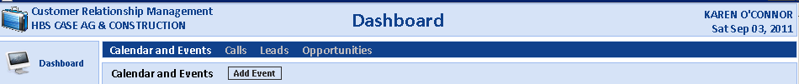

This brings up a full display of all the leads (for an individual salesman or all salesmen). They sort so the most current ones are at the top.

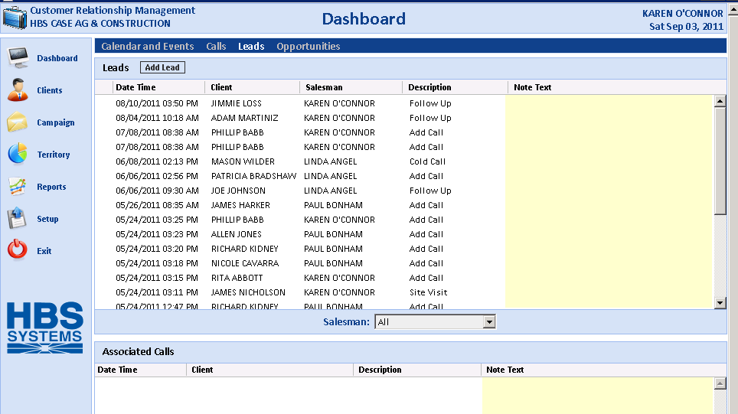

You can review lead information by clicking on it.

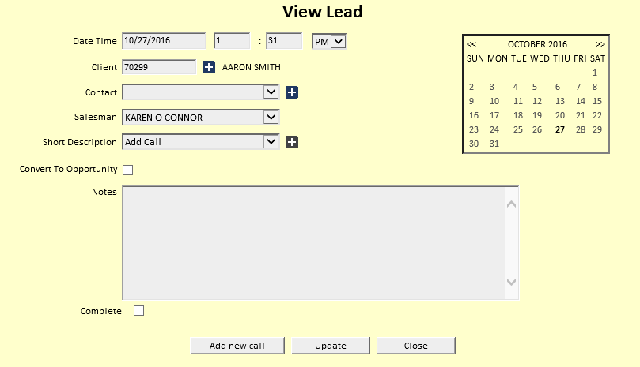

Add a Lead: To add a lead, click the Add Lead button.

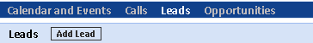

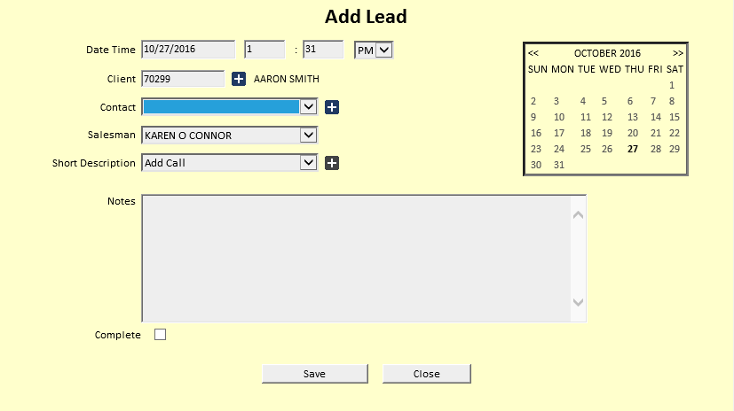

Date and Time: The Date and Time pre-fill with today's date and the current time. Change as needed.

Client: Type in the A/R Customer Number, or look up the customer by typing in a few letters of their last name or business name.

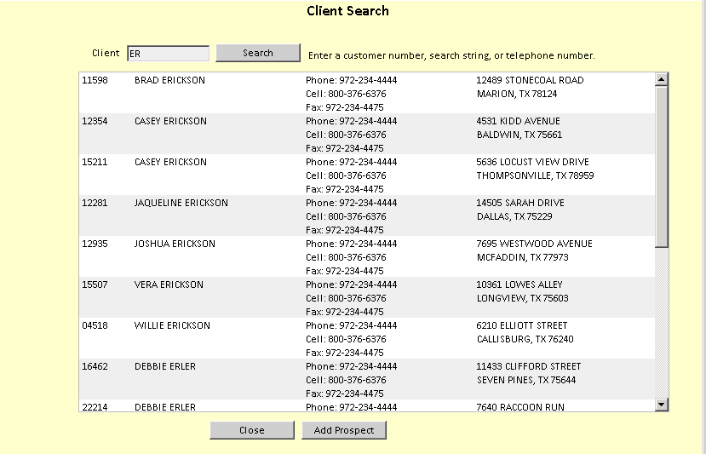

Contact: Choose a contact name from the drop-down menu. If you want to add a new contact:

- Click on the plus (+) sign.
- Fill in the fields that appear.
- Click Save.

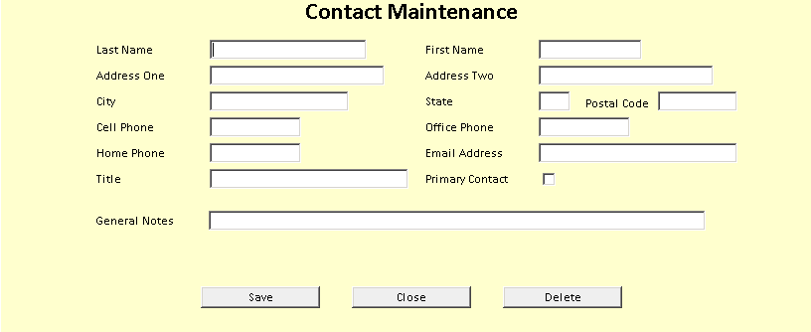

Salesman: The Salesman will default to your login. Sales Managers may choose individual salesman IDs.

Short Description: Choose an option from the drop-down menu.

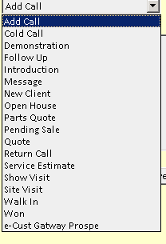

Notes: Fill in more details of the lead as needed.

Complete: Check this box to change the lead status from Active to Closed.

Press “Save” to record the Lead information.

Add from the Client screen: You may also add leads from the Client screen.

Choose a client.

Click on Leads in the lower portion of the screen.

Click Add Lead.

